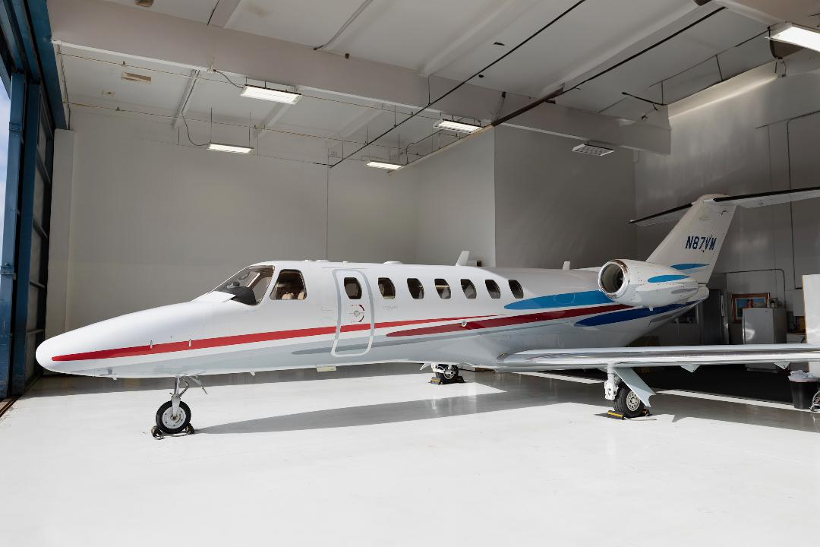

N87VM CJ3 525B S/N 0098

ACTT 2439.1

Cycles 2058

E1TTSN 2439.1 Cycles 2058 Check 3 Complied with at 2040.1/1715

E2TTSN 2439.1 Cycles 2058 Check 3 Complied with at 2040.1/1715

Engines on TAP Blue

Aircraft Definition

Pro Line 21 Integrated autopilot/Flight Director/EFIS-Collins

Pro Line CNS Radios-Collins

Dual Radio Tuning Units-Collins

Dual TDR-94 Transponders-ADS-B

FMS-3000 w/GPS-Collins

FMS Performance Database-Collins

GPS-500-Garmin

HF-9000 Communications Provisions only

FA2100 Cockpit Voice Recorder Provisions only

Skywatch HP TCAS 1-L-3 Communications

Mark VIII Enhanced Ground Proximity Warning System

C406-2 ELT-Artex

Broadcast Graphical Weather Display /w XM-Collins

HectoPascal/Inch Switch for Baro Units

Cockpit Speaker Mute Switch

Pilots Angle of Attack Indexer-Safe Flight

Electronic Charts-Jeppesen

Voice Annunciator

Oxygen-50 Cubic Foot Bottle

EROS Oxygen Masks-Intertechnique

Tail Logo Light-De Vore

Mobil Jet II

Nickel Cadmium Battery 44 Amp

Monorail Sunvisor

Headset Hooks

One Piece Cockpit Curtain with Two Book Nav Chart Case

ST-3100 Iridium Telephone System-AirCell

110 volt electrical outlet with 5000 Watt Inverter

Cabin Information Display Monitor

XM Radio with 4 Channel Receiver at Each Pedestal Seat

Center Club Seating, RH Fwd Slimline Refreshment Center

RH Side Facing Seat

Over Water Life Vests

LH Forward Storage Cabinet

Executive Tables with Leather Table Top

Aft Divider Assy w/Sliding Doors

Chime Unit

LED Indirect Lighting

Dropped Aisle Lighting

LH Belted Flushing Toilet w/Center Aft Coat Rack

Aft Lowboy Storage Cabinet

Aft Baggage Compartment Carpet